Software Architecture Document (SAD): EchoHire

1. Introduction

1.1 Purpose
This document provides a comprehensive architectural overview of EchoHire, an intelligent multi-modal RAG interviewer and career optimization system. It serves as a guide for developers, stakeholders, and mentors to understand the system's structure and behavior.

1.2 Scope
EchoHire integrates Retrieval-Augmented Generation (RAG), real-time coding assessment, resume intelligence, and LinkedIn optimization. This document covers the high-level architectural styles, component interactions, and data models.

2. Architectural Representation

2.1 Architectural Style: Hybrid Micro-Layered
The system utilizes a Hybrid Architecture. We use a Microservices style to decouple high-intensity functions (like the Coding Sandbox and AI Engine) and a Layered (N-Tier) style within each service for internal organization.

2.2 Justification
- Scalability: Allows independent scaling of the RAG engine and coding sandbox.
- Security: Isolates the code execution environment from the main system database.
- Modularity: Enables separate development of the Resume Scanner and LinkedIn Optimizer.

3. System Architecture & Decomposition

3.1 Structural Architecture Diagram

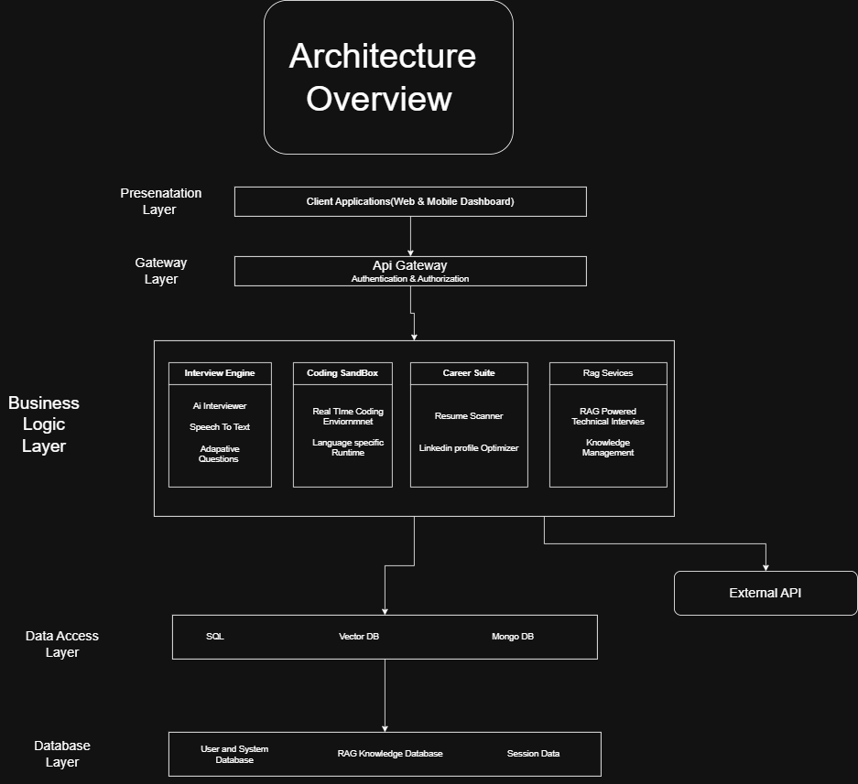
- Description: This diagram illustrates the flow from the client application through the API Gateway to the specific business logic services and specialized databases.

3.2 Functional Decomposition
The system is decomposed into four primary functional pillars:
- Interview Engine: Manages text/voice interaction and adaptive questioning.
- RAG Service: Handles knowledge retrieval from verified datasets and technical documentation.
- Career Suite: Processes resumes for ATS compatibility and optimizes LinkedIn profiles.
- Coding Sandbox: Provides an isolated browser-based editor for technical evaluation.

4. Component View

4.1 Component Diagram (UML 2.0)
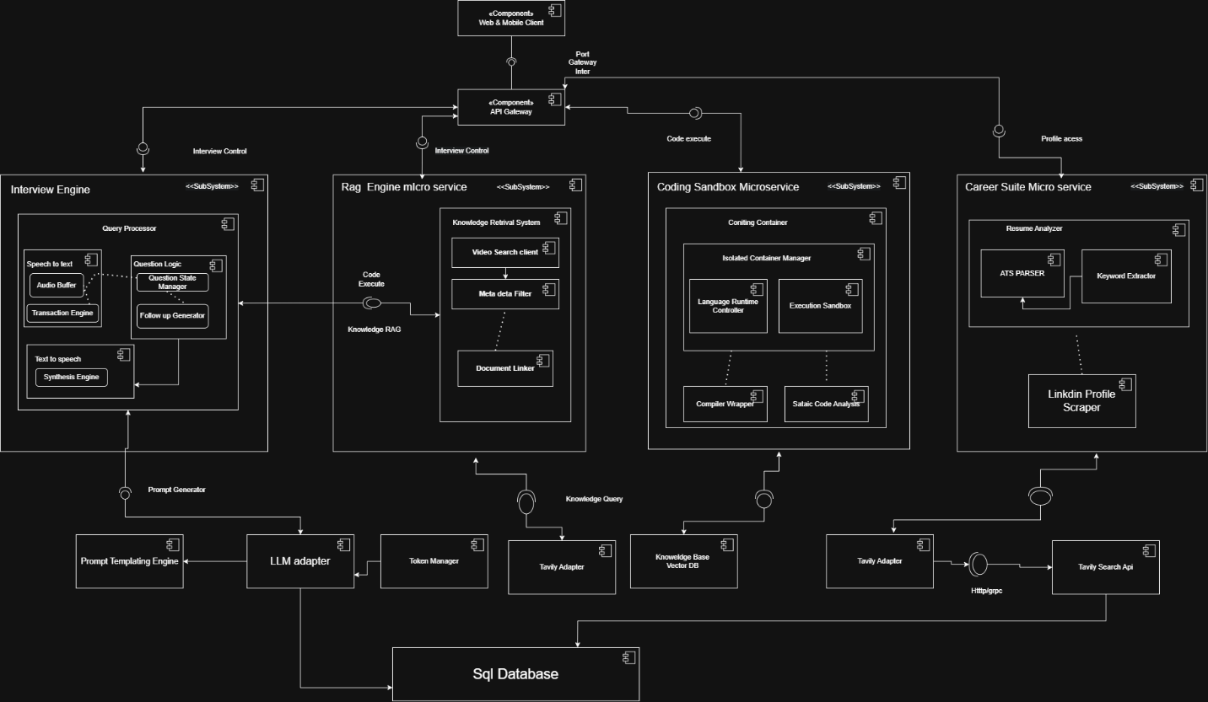
- Description: This diagram shows the internal sub-components, such as the Speech-to-Text service and the isolated container manager, and their connections to external APIs like Tavily and LLMs.

4.2 Interface Specifications
- IInterviewControl: Manages the communication between the UI and the AI engine.
- IKnowledgeRAG: Interface for pulling domain-specific interview questions.
- ICodeExecute: Sends code to the sandbox for complexity analysis.

5. Logical View

5.1 Class Diagram
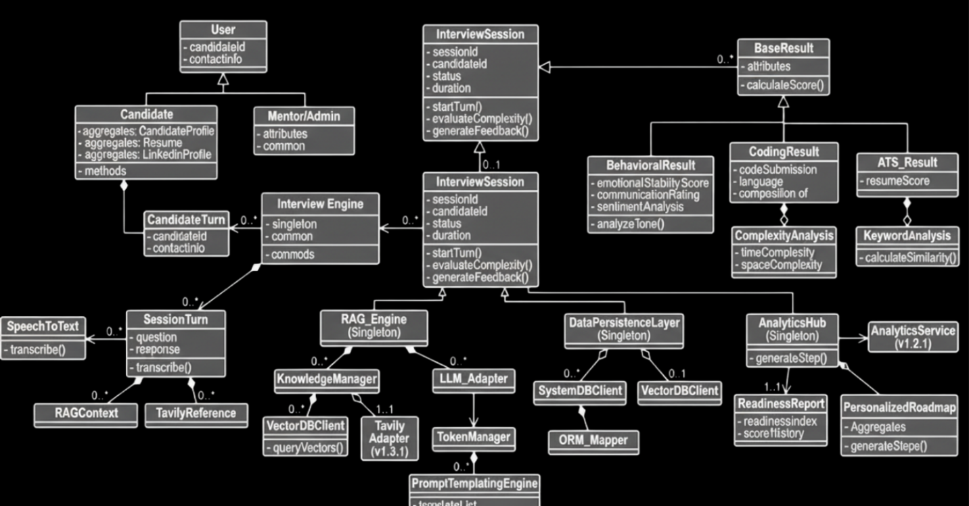
- Description: This diagram defines the entities like InterviewSession, RAG_Engine, and AssessmentResult. It shows how data is structured to generate the Interview Readiness Index.

6. Data View

6.1 Persistence Strategy
The system employs a multi-database strategy:
- Vector Database: Stores semantic embeddings for the RAG knowledge base.
- Relational Database (SQL): Manages user profiles, resumes, and interview transcripts.
- Redis: Used for real-time state management during live interviews.

7. Conclusion
This architecture ensures that EchoHire remains a scalable, secure, and highly responsive platform for university students and job seekers. By separating concerns into microservices, the system can provide deep technical evaluation without compromising on performance.

